 | Heliophysics  Integrated  Observatory
Project No.: 238969
Call: FP7-INFRA-2008-2
Bastille day: An Example of Magnetic Storms observed by different instruments
Draft

Title: | Document Name
Document No.: | HELIO-WPR2-
Date: | 25 May 2010
Editor:
Contributors:
Distribution: | Project

 | 
Revision History

Version | Date | Released by | Detail
1.0 | 25 May 2010 | N.Aucuit (OBSPARIS) | Original PPT Presentation by Aurélie Marchaudon (LPC2E)

Note: Any notes here.

I. ACE IMF and Solar Wind data………………………………………………………….1

II. Solar and magnetic indices………………………………………………………………2

III. GOES data and neutron monitor………………………………………………………3

IV. GIM maps from GPS TEC……………………………………………………………..4

V. Events list from ground-based observatories…………………………………………..4

I. ACE IMF and Solar Wind data:

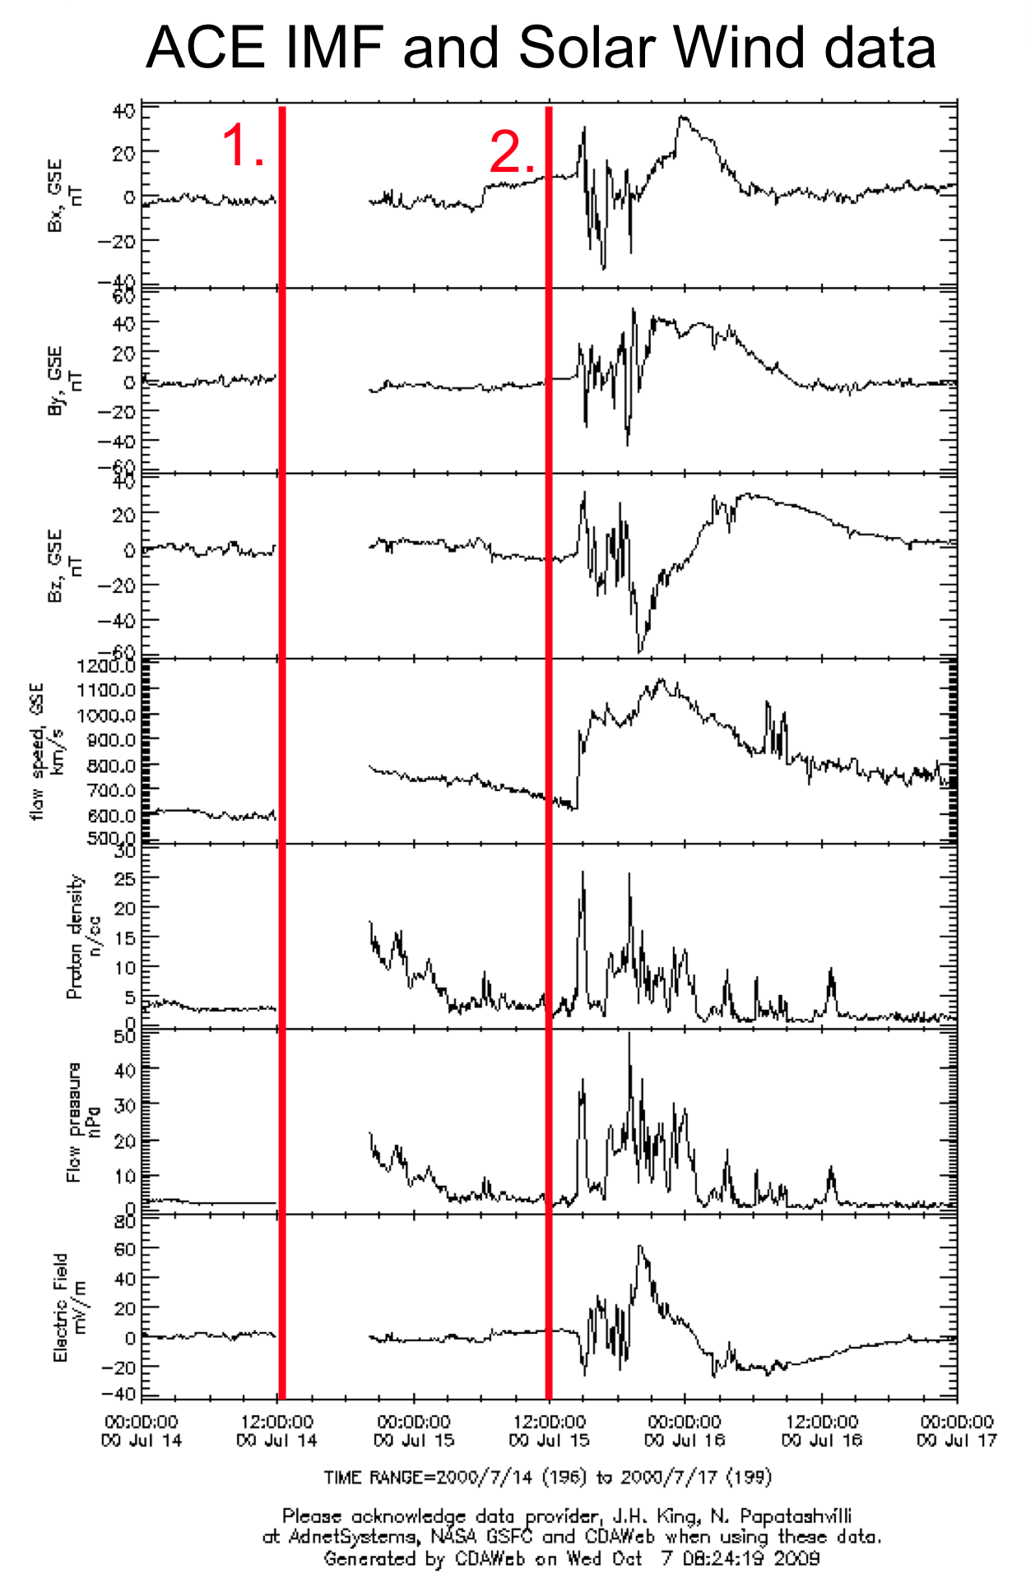
Figure 1

Some magnetic storms happened from 14th to 16th July 2000. This period is divided into 2 main events as in Figure1: Event 1 and Event 2.

During Event 2, we observe strong magnetic perturbations in all components. IMF-Bz is strongly negative after 12:00 UT on 15/07/2000. A solar shock took place so that we can see strong increases of solar wind density, solar wind pressure and electric field.

II. Solar and magnetic indices :

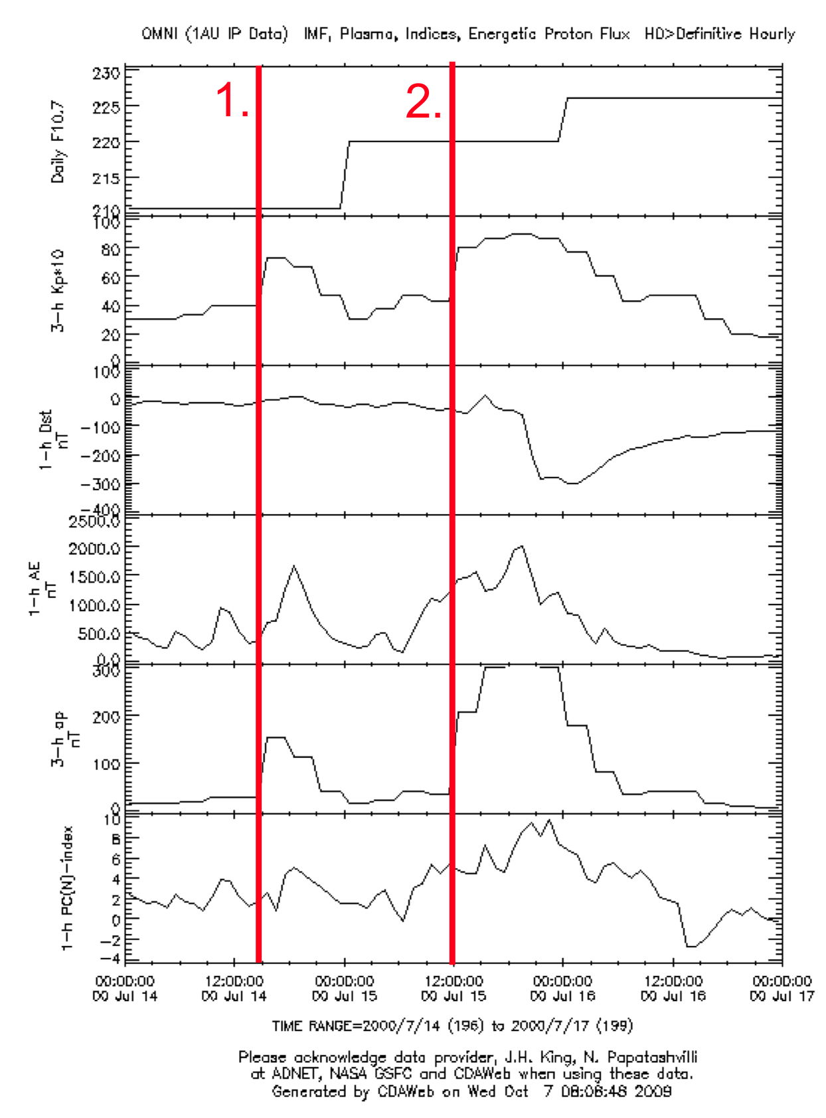
Figure 2

During Event 2, there is a decrease of magnetic Dst index.

During the two Events, there are: - an increase of Solar F10.7 index
- an increase of magnetic Kp index (up to 9)
- increases of magnetic AE, ap (equivalent of Kp in nT) and PCn indices

III. GOES data and neutron monitor :

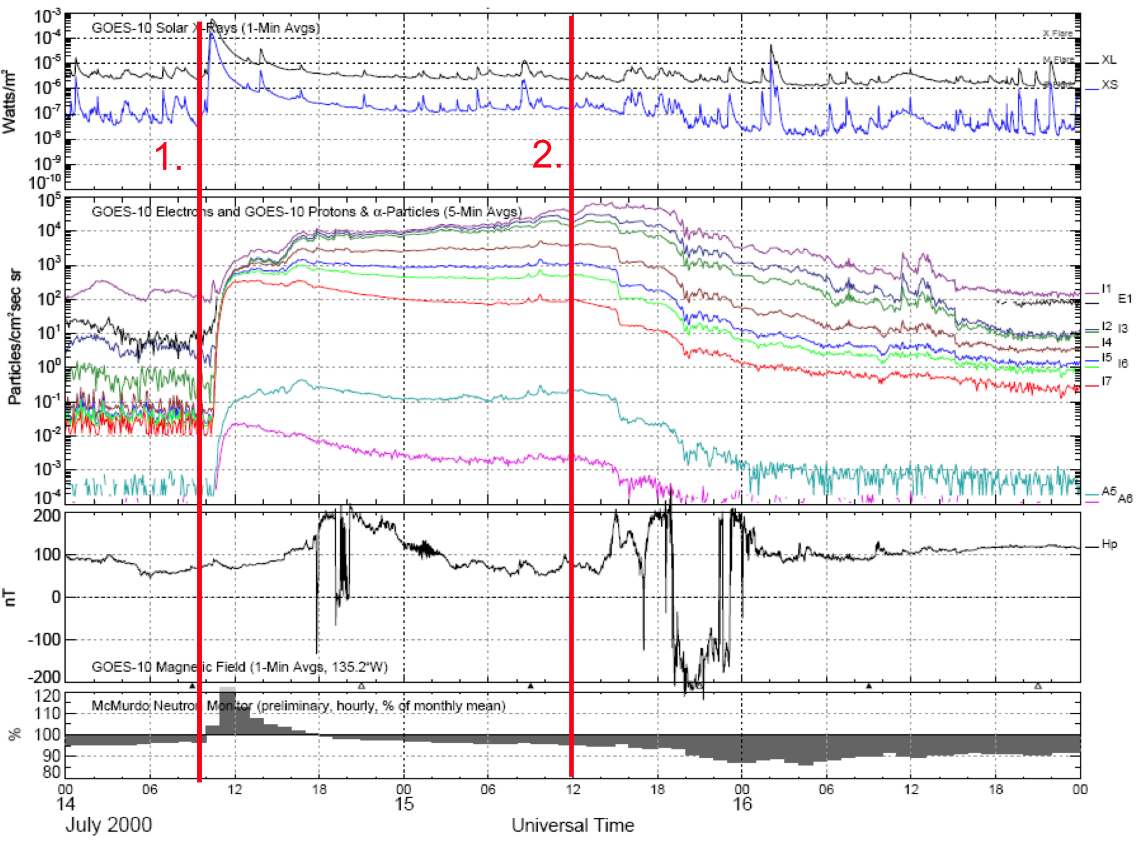

Figure 3

We notice that peaks in X-ray fluxes appear, X-class Flare (Event 1.) and M-class Flare (Event 2.).
The Solar Proton events are the increases in Proton fluxes.
We can see a ground level enhancement in Event 1.

IV. GIM maps from GPS TEC :

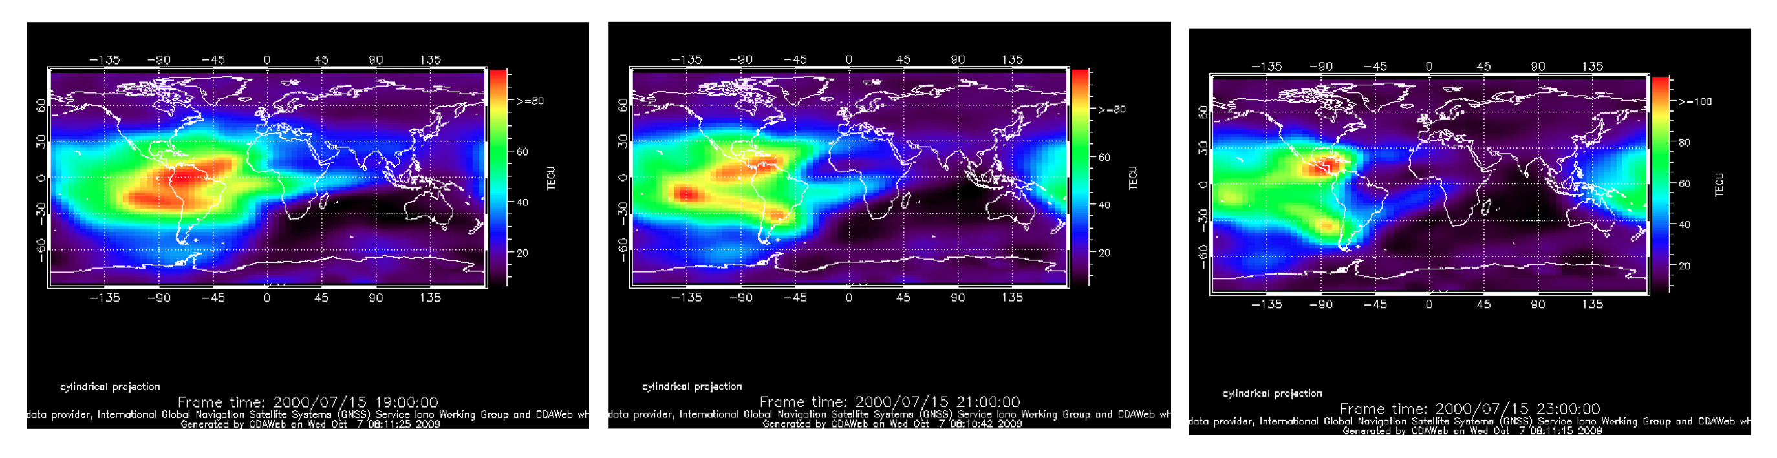
Figure 4

During Event 2, at low latitudes, we observe strong TEC increases.

V. Events list from ground-based observatories:

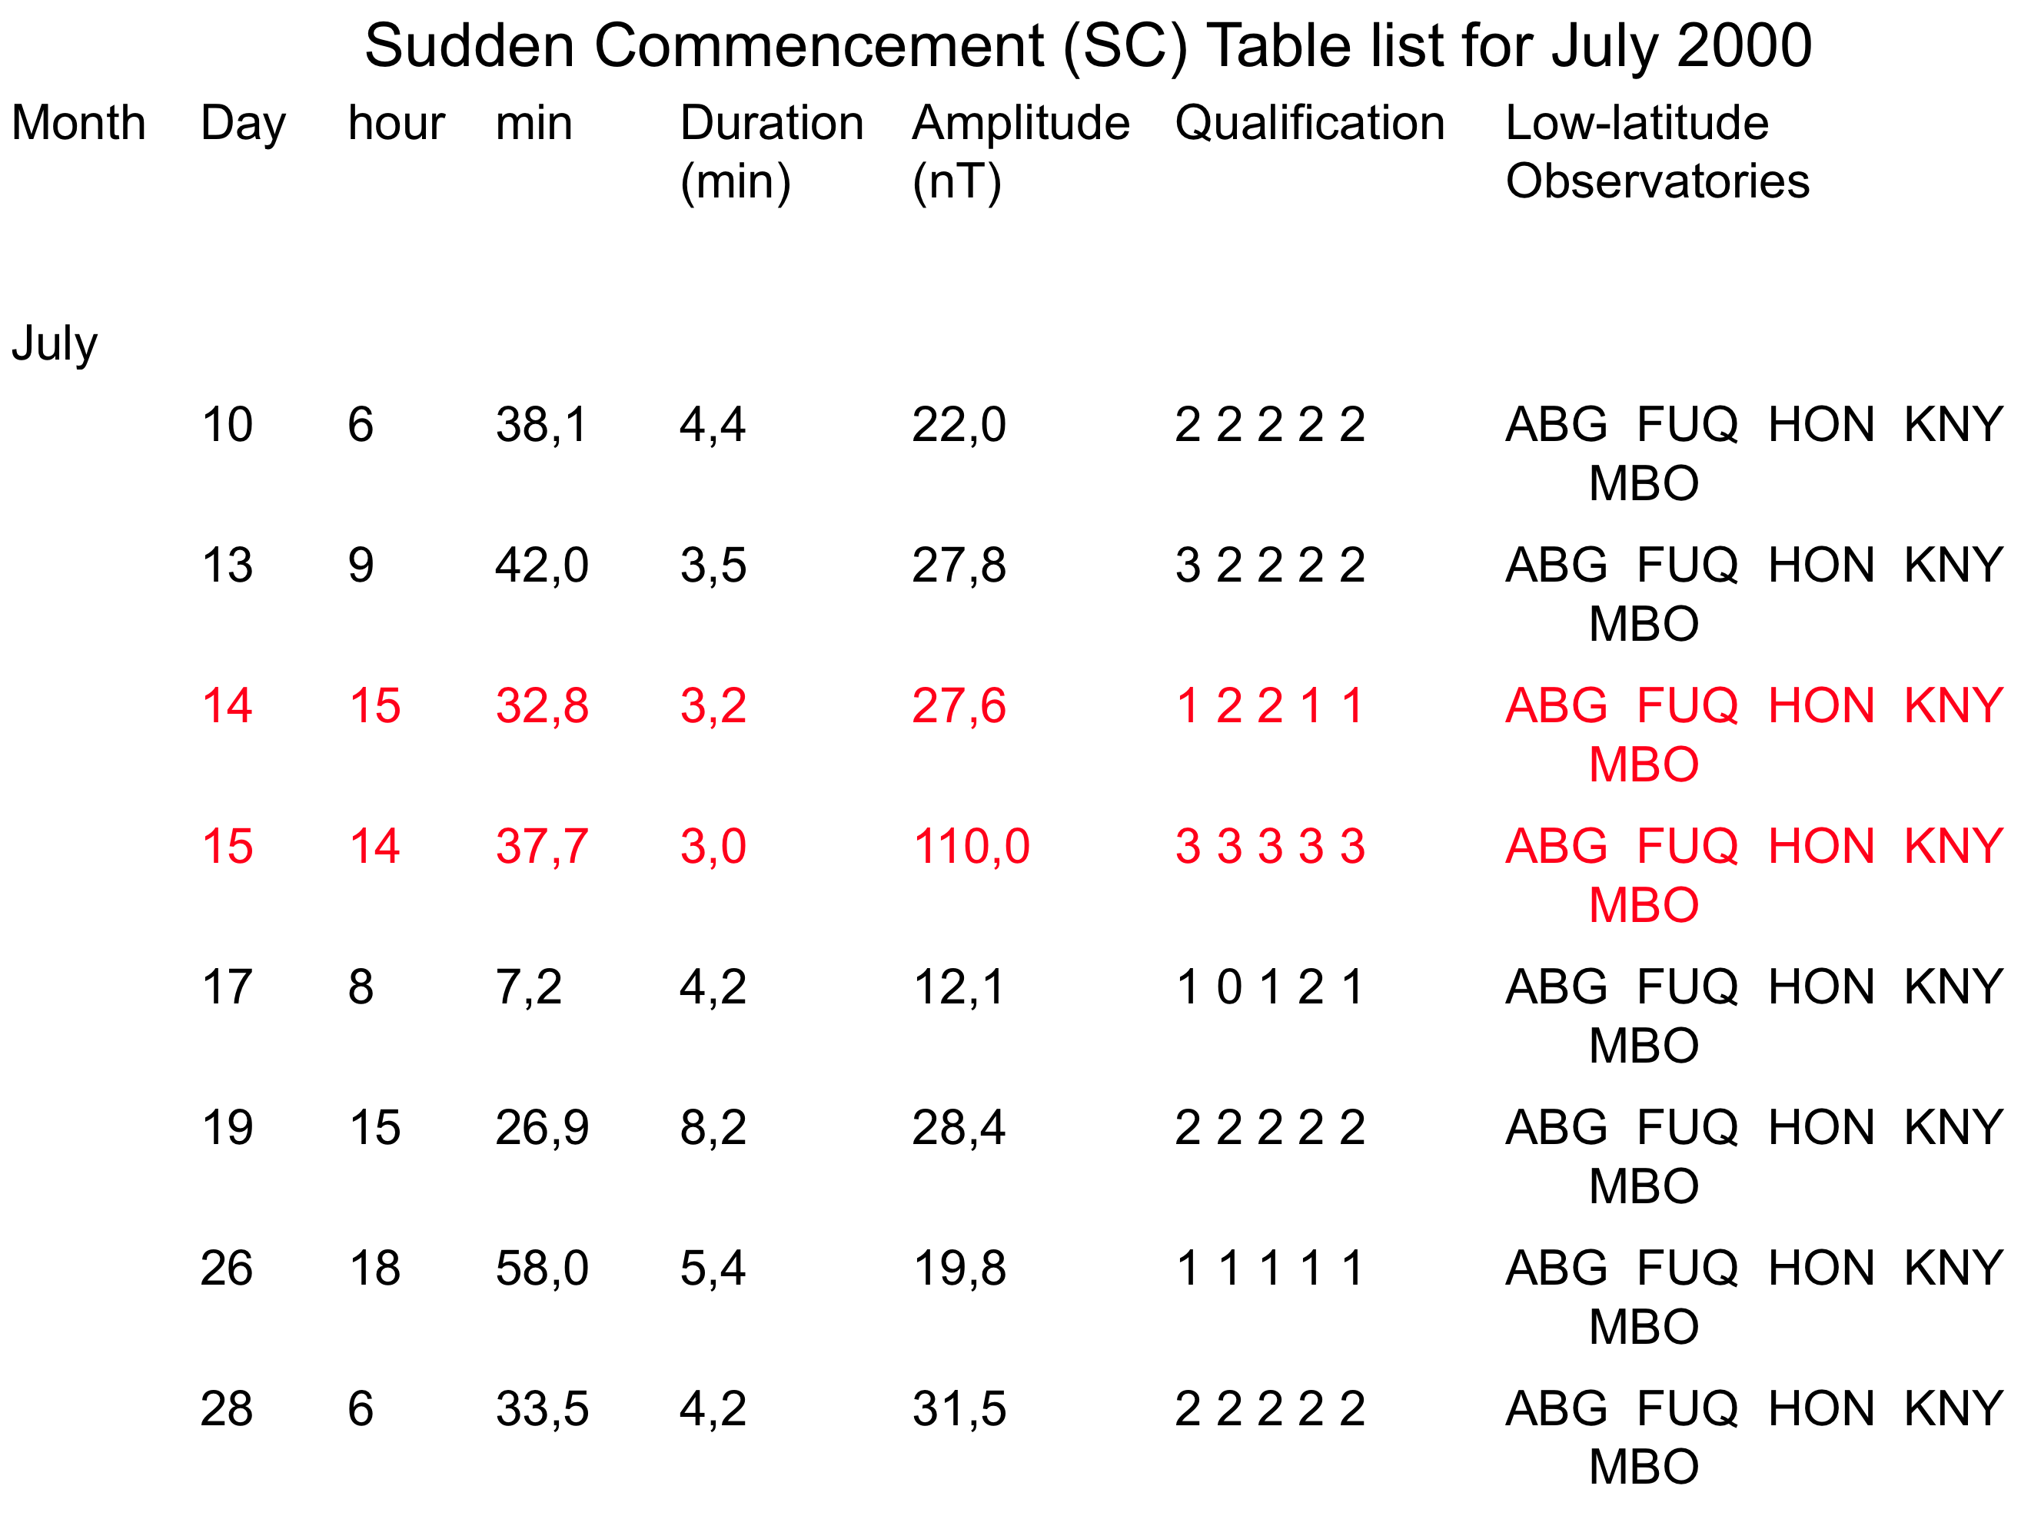

No Solar Flare Effect (SFE) is observed in the list.
Sudden Commencement (SC) is observed in the list, on 14 and 15/07/2000.

